TASK 23
DEPLOY MACHINE ANOMALY DETECTOR TO EC2 INSTANCE

- AWS EC2 Instance Creation and Configuration

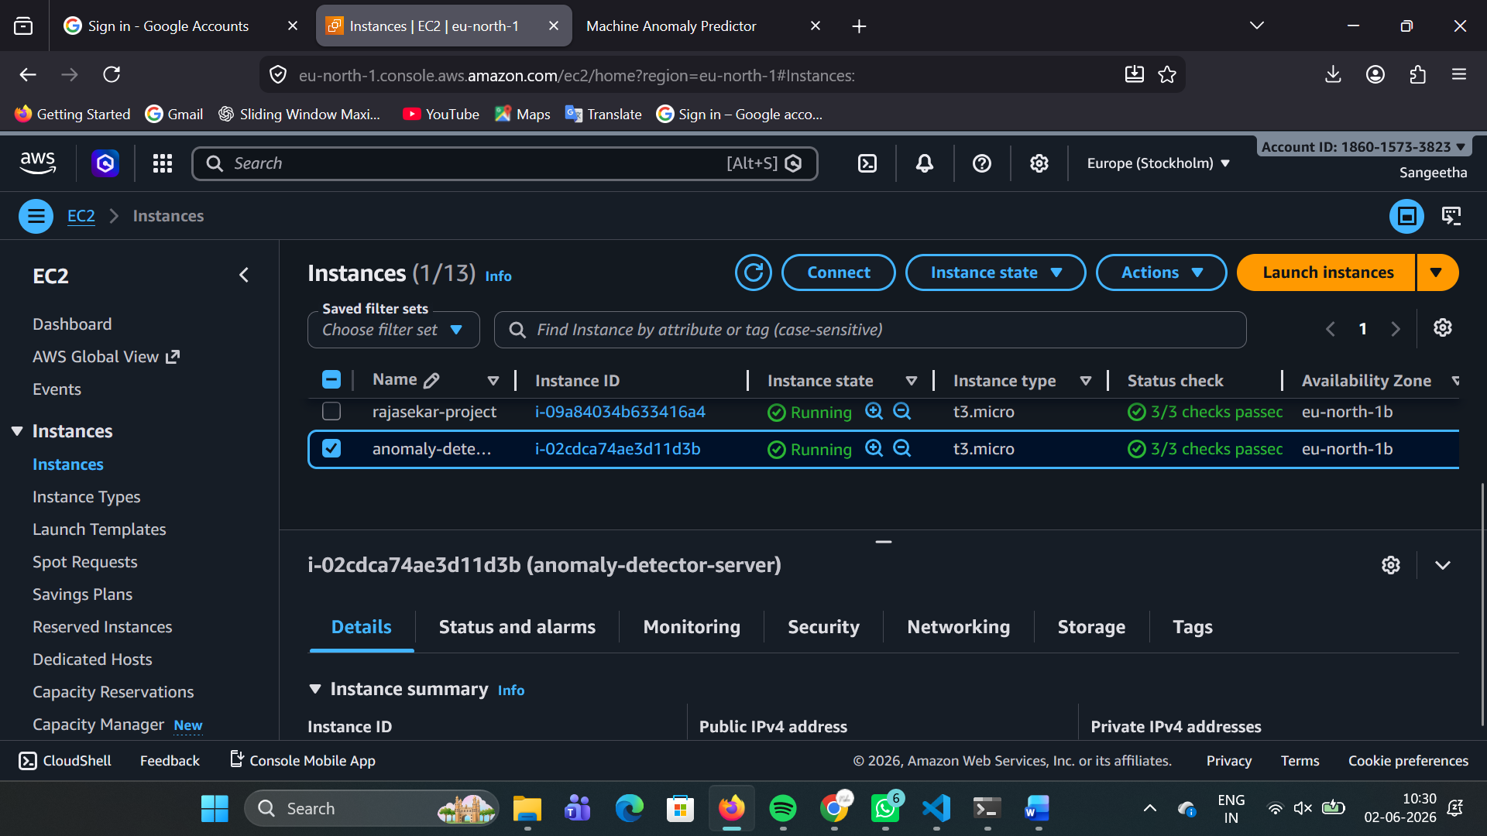

- Smart Factory Anomaly Detector Application Running on AWS Cloud

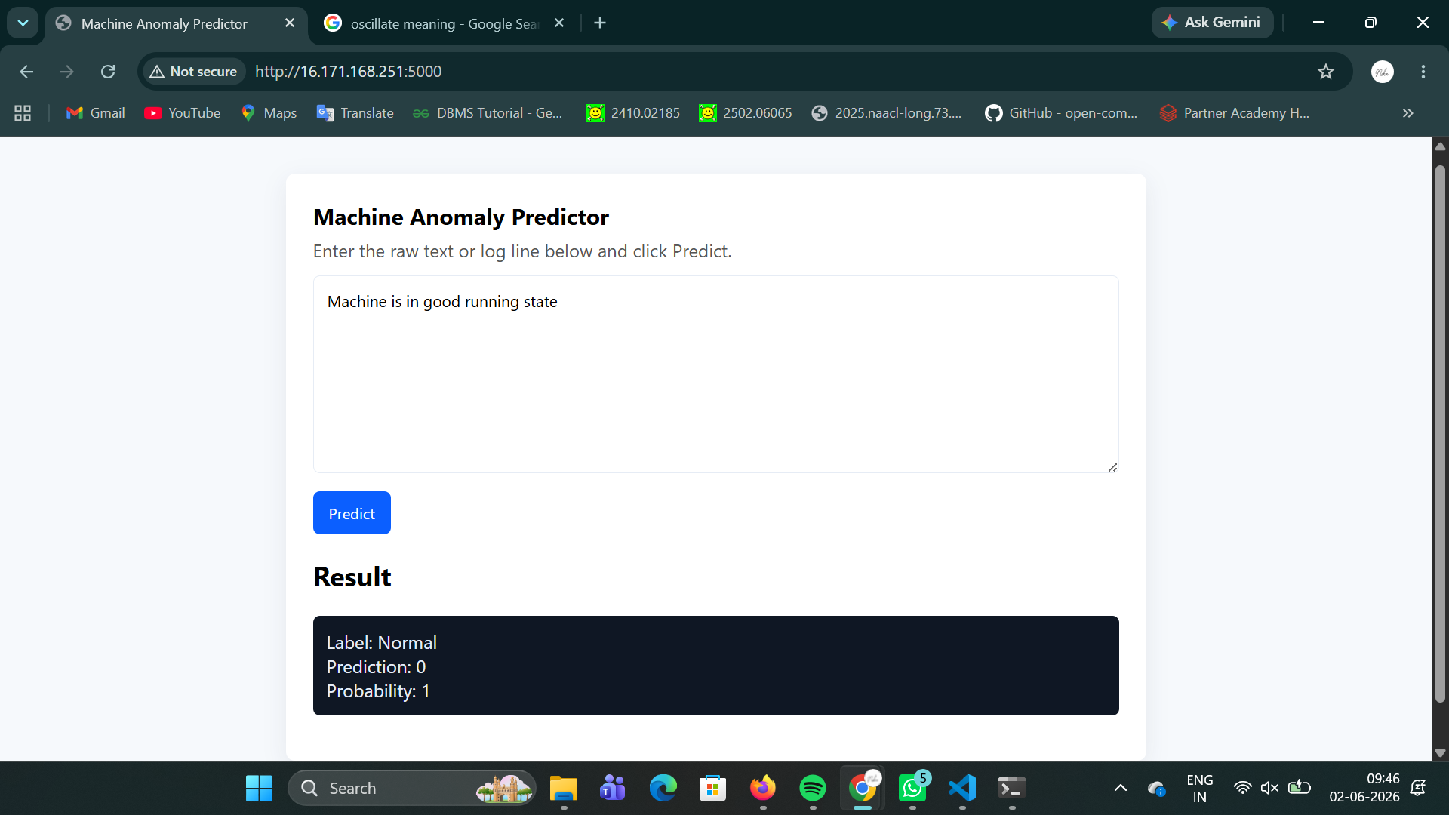

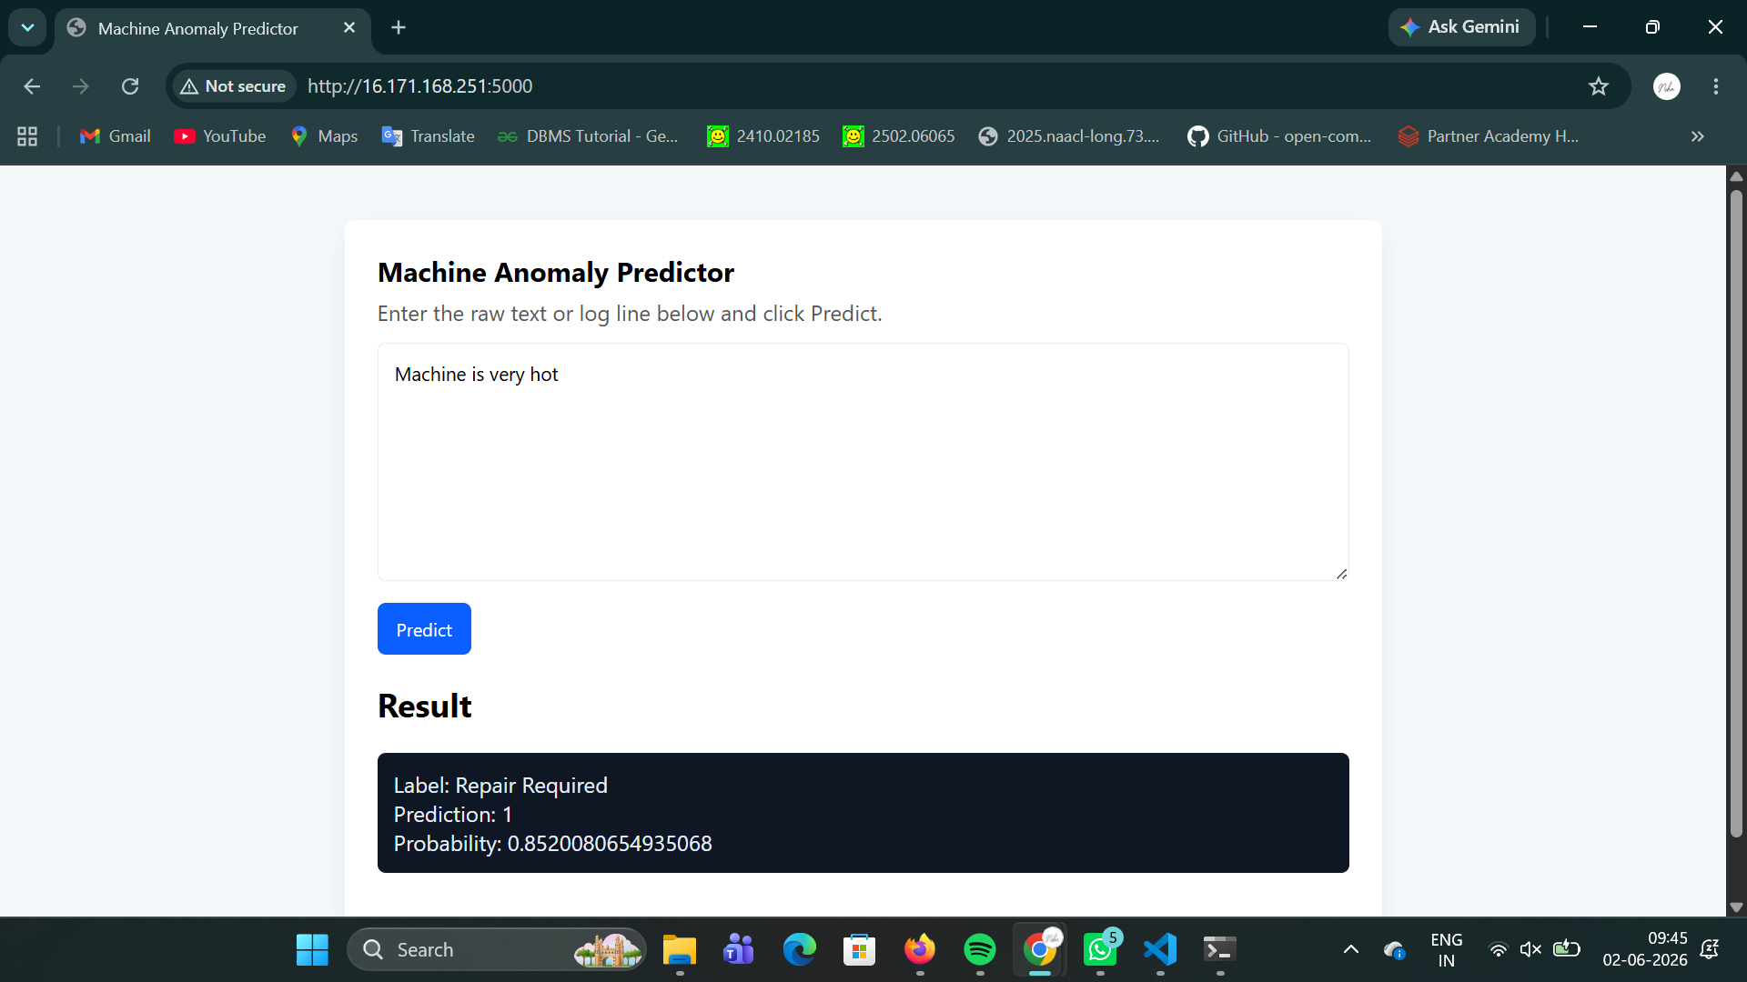

LIVE SERVER : http://16.171.168.251/

